BIOLOGY DEPT
NAMUNGOONA SALAF
GROWTH AND DEVELOPMENT TEST 2

1.Rice seeds were soaked overnight. The fresh mass and dry mass of a sample of 20 seeds was obtained and recorded in the table below. The rest of the
seeds were planted in a tray that had watered soil. 20 of the seeds were removed from the soil every 2 days for two weeks. The fresh and dry mass was recorded as shown in the table below
Time in days | Fresh mass in g | Dry mass in g
0 | 14.0 | 4.0
2 | 18.0 | 3.5
4 | 24.5 | 2.5
6 | 32.0 | 1.5
8 | 38.5 | 2.0
10 | 41.0 | 3.0
12 | 43.0 | 4.5
14 | 45.0 | 6.0

a) Using the same axes, plot a graph to represent t fresh and dry mass over the two weeks period (07mrks)


b) What would be the dry and fresh mass of the seedling at day 9 (02mrks)
i) Fresh mass
.......................................................................................................
ii) Dry mass
...........................................................................................................
c) Account for the change in dry mass and fresh mass from day 0 to day 6
i) Fresh mass (02mrks)
................................................................................................................................
................................................................................................................................
ii) Dry mass (02mrks)
................................................................................................................................
................................................................................................................................
d) Explain the change in dry mass from day 8 (02mrks)
................................................................................................................................
................................................................................................................................
e) Explain why a sample of 20 seeds was used instead of one seed (02mrks)
................................................................................................................................
................................................................................................................................
f) Describe how the dry mass was obtained ( 03mrks)
................................................................................................................................
................................................................................................................................
................................................................................................................................
................................................................................................................................
..............................................................................................................................

2. The setup below is an investigation of the process in living organisms. Study it carefully and answer the questions that follow
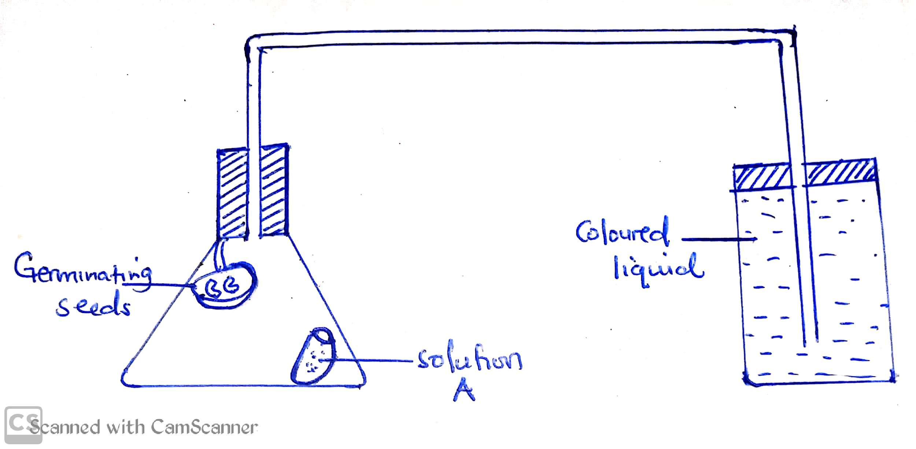

a) What is the aim of the above setup (01mrk)
................................................................................................................................
................................................................................................................................
bi) Name solution A (01mrk)
................................................................................................................................
................................................................................................................................
ii) What is the use of solution A in this experiment (01mrk)
................................................................................................................................
................................................................................................................................
c) state the expected observations (01mrk)
................................................................................................................................
................................................................................................................................
ii) Give an account for the stated observation (04mrks)
................................................................................................................................
................................................................................................................................
................................................................................................................................
................................................................................................................................
d) State 3 precautions that should be taken into consideration in setting up this experiment? (03mrks)
................................................................................................................................
................................................................................................................................
................................................................................................................................
3. Define seed dormancy (01mrk)
................................................................................................................................
................................................................................................................................
b) Outline how seed dormancy may be caused (03mrks)
................................................................................................................................
................................................................................................................................
.............................................................................................................................
c) How can seed dormancy be broken artificially ( 03mrks)
................................................................................................................................
................................................................................................................................
................................................................................................................................
d) State any 3 differences between a dicot and monocot seed (03 marks)
................................................................................................................................
................................................................................................................................
..............................................................................................................................

Section C

4a) what is growth?
b) Name the main parts responsible for producing growth in a shoot
c) Describe an experiment you would perform to determine the region of most rapid elongation in root of a been seedling
5 Measuring fresh weight and dry weight are some of the parameters used to measure growth
a) What are the advantages and disadvantages of measuring growth using fresh weight
b) Of what disadvantage is measuring growth basing on dry weight
c) State other parameters that can be used to determine growth

